**Lab 6**

**Name:** Etcherla Sai Manoj **Mis. No:** 112015044 **Branch:** CSE

**Question1:**

**Code:**

#include<iostream>

#include<cstring>

using namespace std;

class BasicInfo{

public:

string emp_name, gender;

int emp_ID;

void setBasicInfo(){

cout << "Enter employee name : ";

cin >> emp_name;

cout << "Enter employee i.d. : ";

cin >> emp_ID;

cout << "Enter employee gender : ";

cin >> gender;

}

void getBasicInfo(){

cout << "Employee name : ";

cout << emp_name << endl;

cout << "Employee i.d. : ";

cout << emp_ID << endl;

cout << "Employee gender : ";

cout << gender << endl;

}

};

class DeptInfo{

public:

string dep_name;

int depID;

void setDeptInfo(){

cout << "Enter department name : ";

cin >> dep_name;

cout << "Enter department i.d : ";

cin >> depID;

}

void getDeptInfo(){

cout << "Department name : ";

cout << dep_name << endl;

cout << "Department i.d : ";

cout << depID << endl;

}

};

class Employee : public BasicInfo, public DeptInfo

{

public:

void getEmpInfo(){

cout << "\n------------Employee Details------------\n";

getBasicInfo();

getDeptInfo();

cout << "----------------------------------------\n";

}

};

int main(){

Employee e1;

e1.setBasicInfo();

e1.setDeptInfo();

e1.getEmpInfo();

return 0;

}

**Input & Output:**

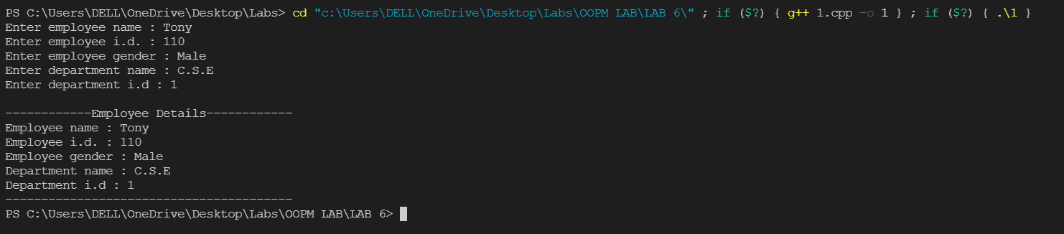

**Question2:**

**Code:**

#include<iostream>

using namespace std;

class A{

public:

A(){

cout << "Class A is accessed.\n";

}

};

class B : public A{

public:

B(){

cout << "Class B is accessed\n";

}

};

class C : public B{

public:

C(){

cout << "Class C is accessed.\n";

}

};

int main(){

C c1;

return 0;

}

**Input & Output:**

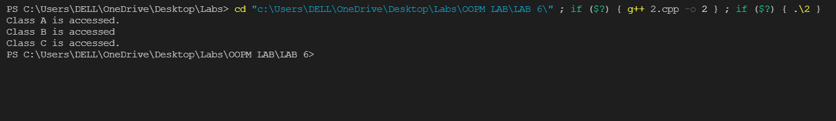

**Question3:**

**Code:**

#include<iostream>

using namespace std;

class class_1{

int a;

public:

class_1(){

cout << "class_1 default constructor.\n\n";

}

class_1(int a){

cout << "\nclass_1 is accessed.\n";

cout << "class_1 parameterized constructor.\n\n";

}

};

class class_2 : public class_1{

int b;

public:

class_2(){

cout << "class_2 default constructor.\n\n";

}

class_2(int b) : class_1(b){

cout << "class_2 is accessed.\n";

cout << "class_2 parameterized constructor.\n\n";

}

};

int main(){

class_2 d1(10);

return 0;

}

**Input & Output:**

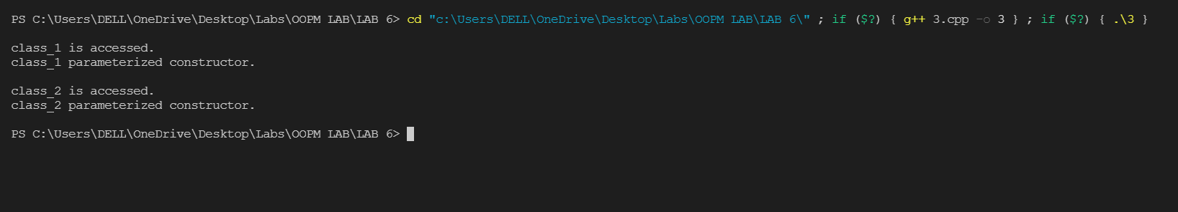

**Question4:**

**Code:**

#include<iostream>

using namespace std;

class Vehicle{

public:

Vehicle(){

cout << "This is a Vehicle\n";

}

};

class Car : public Vehicle{

public:

Car(){

cout << "This is a Car\n";

}

};

class Bike : public Vehicle{

public:

Bike(){

cout << "This is a Bike\n";

}

};

int main(){

int n;

cout << "\nEnter number of tyres : ";

cin >> n;

cout << "-----------------Vehicle Details----------------\n";

if(n == 2){

Bike b1;

}

else if(n == 4){

Car c1;

}

else{

Vehicle v1;

}

cout << "-------------------------------------------------\n";

return 0;

}

**Input & Output:**

